DESIGN AND ANALYSIS OF ALGORITHMS
ASSIGNMENT 2 – CO2
Solved Answers with Algorithms, Test Data, Operation Counts and Analysis
Student Name:C Kiran Kumar Reddy
Register Number:192524181
Course/Section: CSA0601 Submission Date: 29-10-2026

Q1. Sorting Under Different Data Conditions (6 marks)

1.1 The real-world problem
A fulfilment centre must arrange customer orders by dispatch priority score. The input may be random, already sorted, nearly sorted or badly disordered. The question is whether one of Selection, Bubble or Insertion Sort should always be preferred, or whether the best choice depends on the data.

1.2 How each algorithm works
Let the array be a[0..n-1], sorted ascending.
- Selection Sort – For each position i, scan the unsorted part a[i..n-1] to select the smallest element, then swap it into position i. The scan always runs in full, so comparisons are always n(n−1)/2 whatever the data looks like. At most one swap per pass, so at most n−1 swaps (very few writes).
- Bubble Sort – Repeatedly compare neighbours a[j] and a[j+1] and swap if out of order, so the largest remaining element "bubbles" to the end each pass. With an early-exit flag (stop after a pass with no swap) a sorted array needs only one pass. Small elements can move left only one position per pass – this is why it is slow when a small value sits near the end.
- Insertion Sort – Keep a sorted prefix. Take the next element (the key), shift larger prefix elements one place right, and drop the key into the gap. If the key is already in place, the inner loop stops after one comparison.
An inversion is a pair (i<j) with a[i] > a[j]; it measures disorder. Insertion Sort performs exactly one shift per inversion, so its work is about (n−1) + inversions. A sorted array has 0 inversions; a reverse-sorted array has n(n−1)/2.

1.3 Complexity
Algorithm | Best | Average | Worst | Extra space | Stable?
Selection | n(n−1)/2 cmp (always) | n(n−1)/2 | n(n−1)/2 | O(1) | No
Bubble (early exit) | n−1 cmp | ~n²/2 cmp | n(n−1)/2 cmp | O(1) | Yes
Insertion | n−1 cmp | ~n²/4 | n(n−1)/2 | O(1) | Yes
Why Insertion Sort suits nearly sorted data: its work is proportional to n + inversions. If only a few elements are out of place, inversions are small, so the work is close to linear.
1.4 Flowcharts
Figure 1.1 – Selection Sort
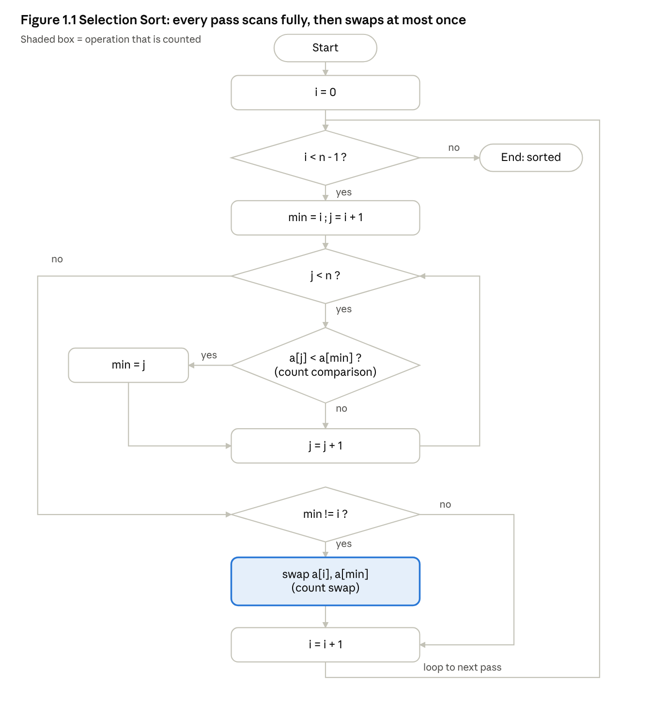
Selection Sort flowchart · 4 decisions, 1 counted swap
Figure 1.2 – Bubble Sort (with early exit)
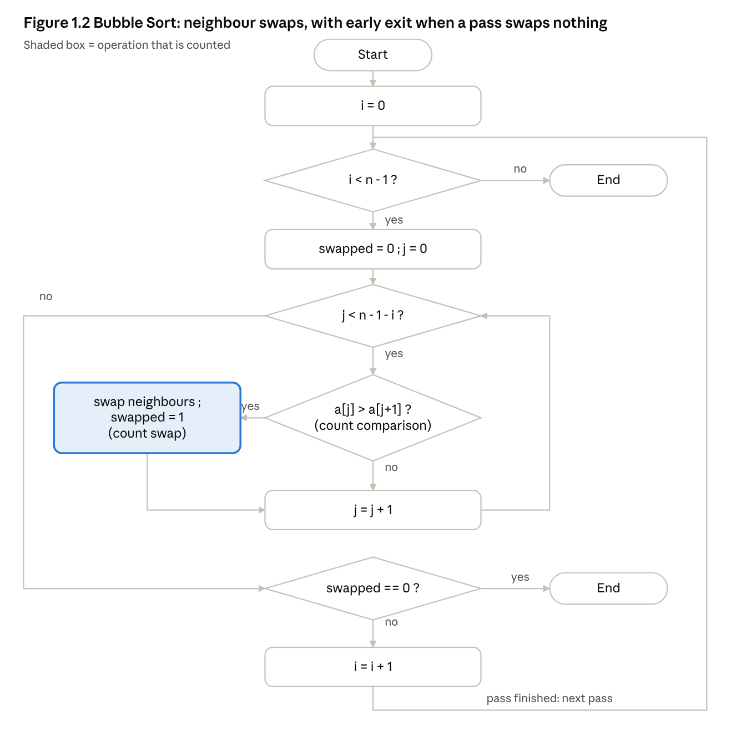
Bubble Sort flowchart · early exit when swapped = 0
Figure 1.3 – Insertion Sort
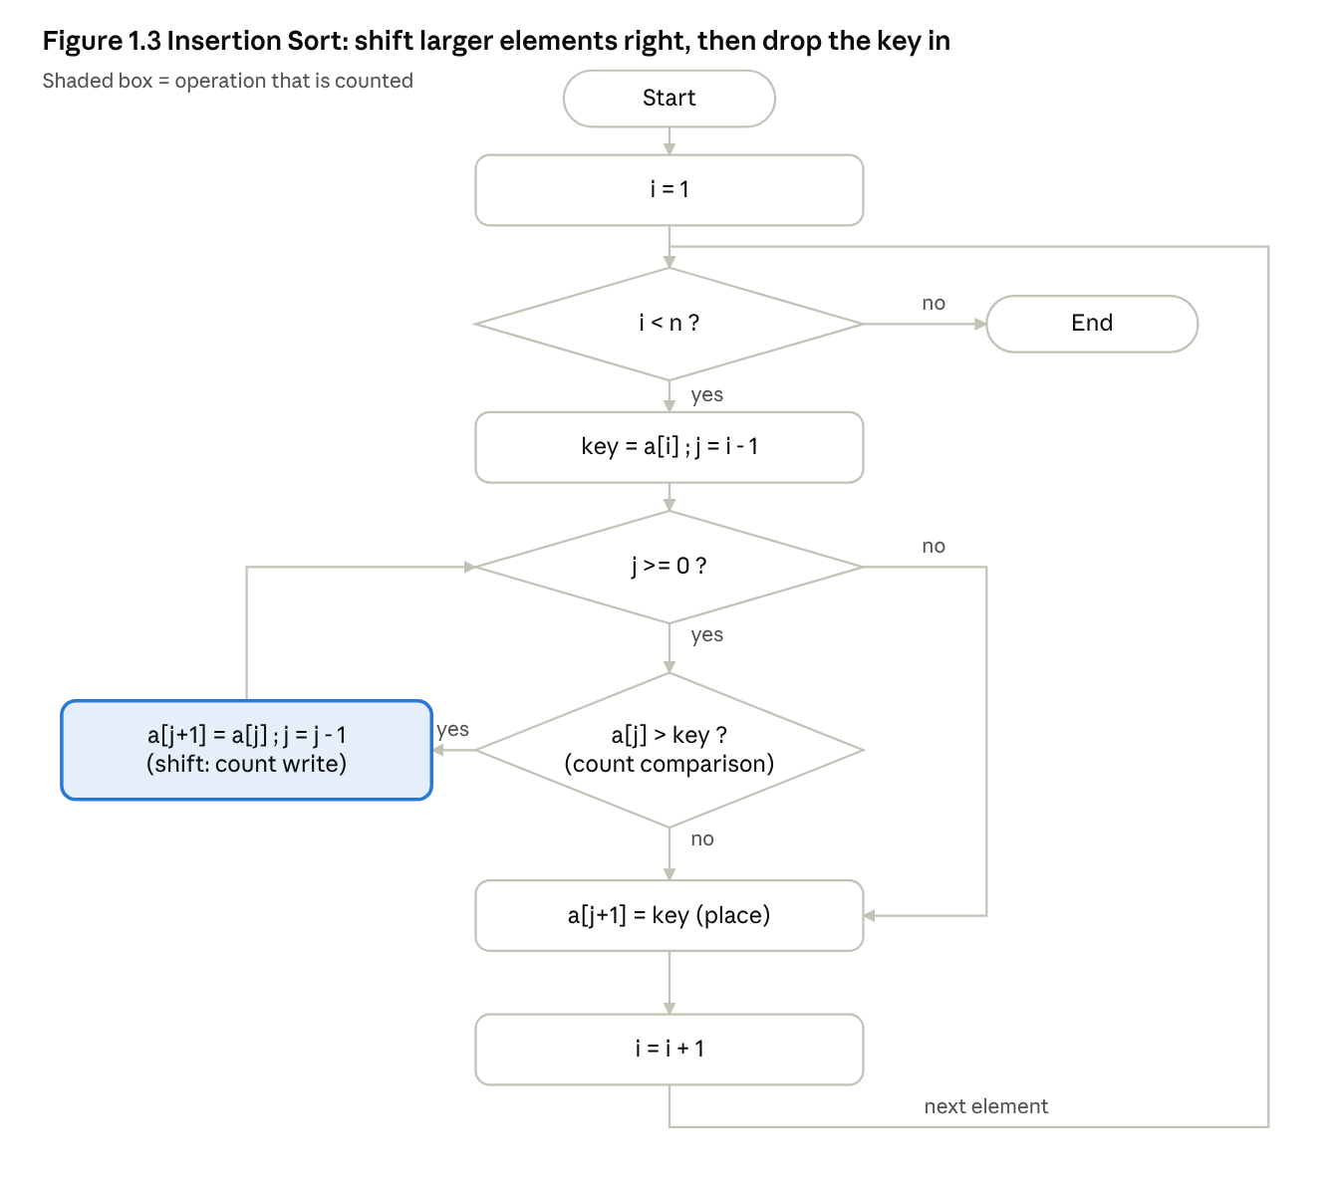
Insertion Sort flowchart · shifts counted as writes

1.5 Worked example (hypothetical priority scores)
Input: [29 10 14 37 13 5 22 18] (Measured trace from the program, array after each pass).
Pass | Selection | Bubble | Insertion (after inserting a[i])
1 | 5 10 14 37 13 29 22 18 | 10 14 29 13 5 22 18 37 | 10 29 14 37 13 5 22 18
2 | 5 10 14 37 13 29 22 18 | 10 14 13 5 22 18 29 37 | 10 14 29 37 13 5 22 18
3 | 5 10 13 37 14 29 22 18 | 10 13 5 14 18 22 29 37 | 10 14 29 37 13 5 22 18
4 | 5 10 13 14 37 29 22 18 | 10 5 13 14 18 22 29 37 | 10 13 14 29 37 5 22 18
5 | 5 10 13 14 18 29 22 37 | 5 10 13 14 18 22 29 37 | 5 10 13 14 29 37 22 18
6 | 5 10 13 14 18 22 29 37 | 5 10 13 14 18 22 29 37 (no swap → stop) | 5 10 13 14 22 29 37 18
7 | 5 10 13 14 18 22 29 37 | – | 5 10 13 14 18 22 29 37
Notice Selection keeps making passes even after the array is sorted (passes 6–7), while Bubble stops at pass 6 thanks to the flag.

1.6 Counting rules (used consistently in code)
- Comparison (cmp): every comparison between two array elements (a[j]<a[min], a[j]>a[j+1], a[j]>key). Loop-counter tests are not counted.
- Swap (swp): every exchange of two array elements. Insertion Sort uses shifts, so its swap count is 0.
- Write (wr) = element movements: every assignment into the array. A swap = 2 writes, a shift = 1 write, placing the key = 1 write (only if the key actually moved). This lets all three algorithms be compared on one scale.

1.7 Experimental design and predictions (n = 1000)
Dataset | Description | Predicted Selection | Predicted Bubble | Predicted Insertion
D1 Nearly sorted (95%) | first 950 sorted, 50 random new orders appended | cmp = 499,500 always | Many passes needed: each small appended value moves left 1 place per pass → cmp close to 499,500 | cmp ≈ n−1 + inversions → far fewer
D1b Sorted + 50 adjacent swaps | tiny local disorder | 499,500 | ≈ 3 passes → ~3,000 cmp | ≈ n−1 + 50 ≈ 1,049 cmp
D2 Reverse sorted | worst case | 499,500 cmp, 500 swaps | 499,500 cmp, 499,500 swaps | 499,500 cmp, ~500,499 writes
D3 Edge cases | all equal; many duplicates; n = 0, 1, 2 | 0 swaps if all equal; still n(n−1)/2 cmp | n−1 cmp on all-equal (strict > never swaps equal items) | n−1 cmp on all-equal; empty/single → 0

1.8 Measured results (n = 1000, Measured)
Dataset | Algorithm | Comparisons | Swaps | Writes | Time (µs)
D1 Nearly sorted 95% | Selection | 499,500 | 962 | 1,924 | 1159.2
 | Bubble | 497,609 | 23,064 | 46,128 | 534.7
 | Insertion | 24,063 | 0 | 23,114 | 16.3
D1b Sorted + 50 adj. swaps | Selection | 499,500 | 50 | 100 | 1156.8
 | Bubble | 2,994 | 50 | 100 | 8.3
 | Insertion | 1,049 | 0 | 99 | 2.2
D1c Fully sorted | Selection | 499,500 | 0 | 0 | 1152.1
 | Bubble | 999 | 0 | 0 | 0.7
 | Insertion | 999 | 0 | 0 | 2.2
D2 Reverse sorted | Selection | 499,500 | 500 | 1,000 | 1161.7
 | Bubble | 499,500 | 499,500 | 999,000 | 3348.9
 | Insertion | 499,500 | 0 | 500,499 | 311.2
D2b Random | Selection | 499,500 | 994 | 1,988 | 1259.4
 | Bubble | 499,395 | 249,872 | 499,744 | 1812.4
 | Insertion | 250,866 | 0 | 250,864 | 286.9
D3a Duplicates (values 0–4) | Selection | 499,500 | 777 | 1,554 | 1234.5
 | Bubble | 480,194 | 208,592 | 417,184 | 1489.5
 | Insertion | 209,590 | 0 | 209,368 | 176.0
D3b All equal | Selection | 499,500 | 0 | 0 | 1165.3
 | Bubble | 999 | 0 | 0 | 1.0
 | Insertion | 999 | 0 | 0 | 1.4
Tiny edge cases (all three correct, all sorted = yes): n = 0 → 0 cmp; n = 1 → 0 cmp; n = 2 {9,3} → 1 cmp, 2 writes.

1.9 Predictions versus observations
- Selection: predicted 499,500 comparisons on every input – confirmed on all datasets. Its work does not depend on the data at all; it only avoids many swaps/writes (1,924 on D1).
- Reverse sorted: predicted n(n−1)/2 = 499,500 comparisons for all three – confirmed; Bubble swaps 499,500 times (1 per inversion) and Insertion shifts 499,500 times.
- D1b / D1c / D3b: Insertion and Bubble were near-linear (999–2,994 comparisons) – confirmed.
- D1 – one prediction needs correction. Insertion Sort was far cheaper (24,063 vs 499,500), as predicted. For Bubble, the prediction "close to 499,500" was also confirmed (497,609), which is the surprising result: although 95% of the array is sorted, the 50 appended values include small ones that must travel ~950 places left, and Bubble moves them only one place per pass, so it still needs nearly n passes. Early exit does not help when disorder is concentrated at the far end. Insertion Sort handles the same data with one shift per inversion.
- Scaling of the 95%-sorted pattern (Measured):
n | Selection cmp | Bubble cmp | Insertion cmp | Insertion wr
500 | 124,750 | 124,540 | 7,828 | 7,353
1000 | 499,500 | 497,609 | 24,063 | 23,114
2000 | 1,999,000 | 1,998,439 | 96,756 | 94,854
4000 | 7,998,000 | 7,994,679 | 356,950 | 353,148
Insertion Sort still grows quadratically here (≈ ×3.7–4 per doubling) because the appended 5% block of random values is itself 0.05n elements with ~0.05n·n/2 inversions against the sorted part. Its constant (≈ 0.045 n²) is, however, ~22× smaller than the others.

1.10 Recommendation for the 95%-sorted fulfilment centre
Recommend Insertion Sort. Evidence: on the D1 data it used 24,063 comparisons versus 497,609 (Bubble) and 499,500 (Selection) – about 20× fewer – and ran ≈ 70× faster than Selection and ≈ 33× faster than Bubble in the timing run (supplementary). On D1b, 1,049 comparisons against 2,994 (Bubble) and 499,500 (Selection). It is stable (equal-priority orders keep arrival order), in place (O(1) memory), and handles empty/single arrays correctly. Selection Sort is only preferable if writes are extremely expensive (it did 1,924 writes vs 23,114); Bubble Sort is never the best of the three here. If the periodic batch of new orders is small, a better engineering variant is to sort just the new batch and merge it, but within the three given algorithms Insertion Sort is the answer.
Answer to the challenge question: no single algorithm is always best. Selection is data-insensitive; Bubble and Insertion adapt to order, but Insertion adapts much better when disorder is concentrated.

1.11 Core C code (full file: q1_sorting.c)
typedef struct { long cmp, swp, wr; } Stats;
static void selection_sort(int a[], int n, Stats *s){
for(int i=0;i<n-1;i++){ int min=i;
for(int j=i+1;j<n;j++){ s->cmp++; if(a[j]<a[min]) min=j; }
if(min!=i){ int t=a[i]; a[i]=a[min]; a[min]=t; s->swp++; s->wr+=2; } } }
static void bubble_sort(int a[], int n, Stats *s){
for(int i=0;i<n-1;i++){ int swapped=0;
for(int j=0;j<n-1-i;j++){ s->cmp++;
if(a[j]>a[j+1]){ int t=a[j]; a[j]=a[j+1]; a[j+1]=t; s->swp++; s->wr+=2; swapped=1; } }
if(!swapped) break; } }
static void insertion_sort(int a[], int n, Stats *s){
for(int i=1;i<n;i++){ int key=a[i], j=i-1;
while(j>=0){ s->cmp++; if(a[j]>key){ a[j+1]=a[j]; s->wr++; j--; } else break; }
if(j+1!=i){ a[j+1]=key; s->wr++; } } }
Edge cases: for n = 0 or 1 the loops never execute, so no out-of-range access happens. Strict > keeps equal elements in order.

Q2. Sequential Search for Aircraft Tool Tracking (4 marks)

2.1 What it is and how it works
Sequential (linear) search examines the list from the first element, comparing each record's Tool ID with the target, and stops at the first match; if the end is reached, the tool is not issued. Each record has Tool ID, Technician ID, Issue Time and Work Bay. It needs no ordering and no preparation, so it suits a list that changes constantly.
Case | Meaning | Comparisons
Best | target is the first record | 1
Average (successful, every position equally likely) |  | (n+1)/2
Worst | target last, or absent | n
Time O(n) (best O(1)); extra space O(1).

2.2 Flowchart (successful and unsuccessful paths)
Figure 2.1
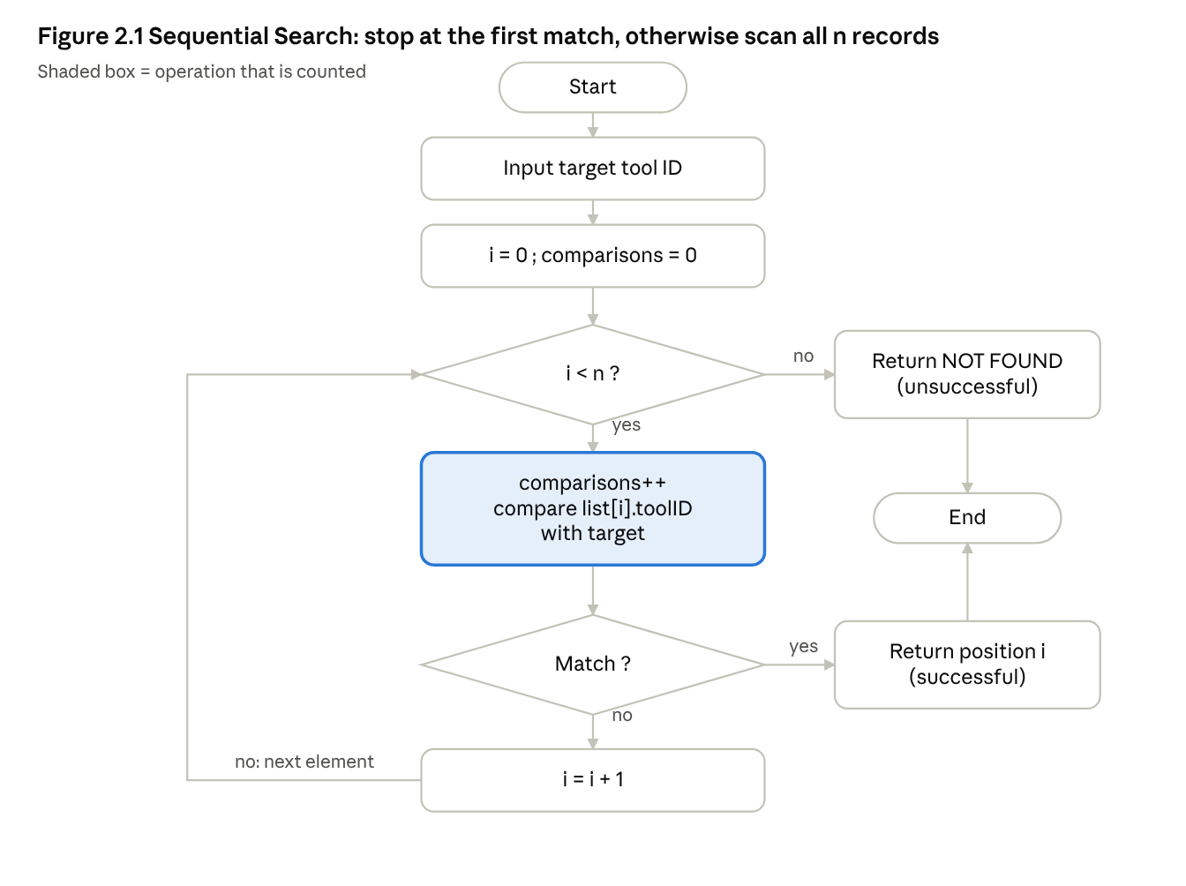
Sequential Search flowchart · successful and unsuccessful paths

2.3 C implementation (full file: q2_seqsearch.c)
typedef struct { int tool_id, tech_id, issue_time, bay; } Record;
static int seq_search(const Record r[], int n, int target, long *cmp){
*cmp = 0;
for(int i=0;i<n;i++){ (*cmp)++; if(r[i].tool_id==target) return i; }
return -1; /* not found */
}
The program builds hypothetical lists of 10, 100, 1,000, 10,000 and 100,000 records (tool IDs 1000…), then searches for the first, middle and last record and an absent ID (999).

2.4 Measured results
List size n | Search type | Target position (0-based) | Comparisons | Predicted
10 | first | 0 | 1 | 1
10 | middle | 5 | 6 | n/2+1 = 6
10 | last | 9 | 10 | 10
10 | unsuccessful | – | 10 | 10
100 | first / middle / last / absent | 0 / 50 / 99 / – | 1 / 51 / 100 / 100 | 1 / 51 / 100 / 100
1,000 | first / middle / last / absent | 0 / 500 / 999 / – | 1 / 501 / 1000 / 1000 | same
10,000 | first / middle / last / absent | 0 / 5000 / 9999 / – | 1 / 5001 / 10000 / 10000 | same
100,000 | first / middle / last / absent | 0 / 50000 / 99999 / – | 1 / 50001 / 100000 / 100000 | same
Average over every successful target (exact): n=10 → 5.50, n=100 → 50.50, n=1000 → 500.50, n=10000 → 5000.50, exactly (n+1)/2. A sample of 1,000 random lookups gave 5.51, 49.31, 503.51, 5174.05 – close to theory, with random sampling noise.
Why first is cheaper than last: the search stops at the first match, so the comparison count equals (position + 1). Why a failed search examines everything: the algorithm cannot know a tool is absent until every record has been checked, so unsuccessful searches always cost n comparisons.

2.5 Operating boundary and the 20-facility change
Total work ≈ (lookups per second) × (average comparisons per lookup ≈ n/2 for hits, n for misses). Updates cost nothing (append on issue, delete on return).
- Reasonable: a single hangar with a few hundred active records and occasional queries (e.g. n = 500 and one lookup a minute ≈ 250 comparisons per minute). The list changes constantly, so a structure that needs maintenance (a sorted array) would cost more than it saves.
- Stop recommending: when n × lookup-rate grows so the lookup delays become noticeable to technicians or the system is shared by many users. With 20 facilities pooled into one list (say 20 × 500 = 10,000 records) each miss costs 10,000 comparisons (measured table above), and the lookup rate also rises ~20×, so total work grows roughly 20 × 20 = 400×. Because both factors multiply, the cost rises much faster than the size alone suggests.
- Better options: a hash table keyed by Tool ID (average O(1) lookup, insert and delete, so it handles the constant issue/return changes well); or keeping a separate list per facility (n stays ≈ 500) if queries are always local. A sorted array with binary search is a poor fit because every issue/return would require O(n) shifting; a balanced search tree is an option if ordered queries are needed. These are recommendations from complexity reasoning, not measured here.

Q3. Brute-Force String Matching for Log Screening (6 marks)

3.1 Terms
Text T (length n): the log. Pattern P (length m): the signature. Alignment i: P placed so that P[0] sits over T[i], for i = 0 … n−m. Character comparison: one test T[i+j] == P[j]. Brute force tries every alignment, comparing left to right until a mismatch or until all m characters match.
Why repeated work occurs: after a mismatch the algorithm moves only one step and starts over at P[0], throwing away what it learned about the text. If the pattern's prefix keeps matching for many characters before failing, the same text characters are compared again at the next alignment.
Case | Work
Best (match at position 0) | m comparisons
Best for a miss (first char mismatches every time) | n−m+1 comparisons
Worst | (n−m+1)·m comparisons → O(nm)
Space: O(1).

3.2 Pattern sliding (hand-traced example, hypothetical)
T = ABABAC (n=6), P = ABAC (m=4). ✓ = matched, ✗ = first mismatch.
Alignment | Text window | Pattern | Comparisons | Result
i=0 | A B A B | A B A C | A✓ B✓ A✓ B✗C → 4 | mismatch at j=3
i=1 | B A B A | A B A C | B✗A → 1 | mismatch at j=0
i=2 | A B A C | A B A C | A✓ B✓ A✓ C✓ → 4 | match at 2
Total 9 comparisons (hand-traced). Note T[2], T[3] were compared at i=0, and T[2], T[3] again at i=2 – repeated comparisons.
Figure 3.1 – Flowchart
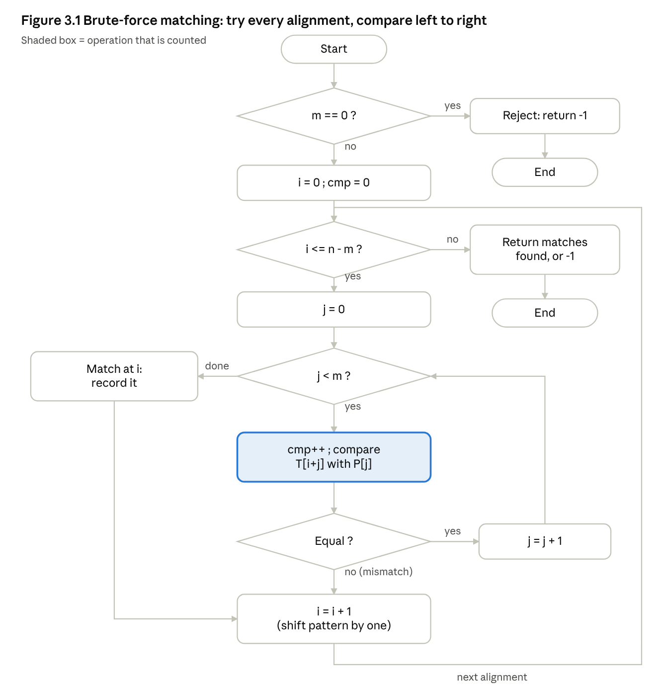
Brute-force string matching flowchart · alignment loop and comparison loop

3.3 Conventions and C code (full file: q3_strmatch.c)
Convention: 0-based positions; all occurrences are reported, overlapping ones included (aa in aaaa matches at 0,1,2); an empty pattern is rejected (returns −1, 0 comparisons); if m > n there are no alignments (0 matches, 0 comparisons). A "first-match" mode stops at the first occurrence.
static int bf_match(const char *T, const char *P, int stop_at_first, Result *r){
int n=strlen(T), m=strlen(P);
r->cmp=0; r->first=-1; r->count=0;
if(m==0) return -1; /* empty pattern rejected */
for(int i=0;i<=n-m;i++){ /* every alignment (none if m>n) */
int j=0;
while(j<m){ r->cmp++; if(T[i+j]!=P[j]) break; j++; }
if(j==m){ if(r->first<0) r->first=i; r->count++; if(stop_at_first) return i; }
} return r->first; }

3.4 Test conditions, predictions and measured results
Test | Text / pattern | Predicted (before running) | Measured
T1 early match | log line (n=94) begins ERROR 503 service…, P=ERROR 503 (m=9) | match at 0, m = 9 comparisons | first=0, 9
T2 engineered worst case | T = A×n, P = A×9 + B (m=10), n=100 | (n−m+1)·m = 91·10 = 910 | 910
T2 | same, n=1000 | 991·10 = 9,910 | 9,910
T2b mismatch-at-first | T = A×1000, P = BAAAAAAAAA | n−m+1 = 991 (1 per alignment) | 991
T3a absent, varied text | n=1000 text over letters a–h, P=zzzz | ≈ n−m+1 = 997 | 997
T3b overlapping matches | T = A×1000, P = A×10, all matches | 991 matches, 991·10 = 9,910 | 991 matches, 9,910
Edge cases (Measured): empty pattern → rejected, 0 cmp; pattern longer than text (abcd in abc) → 0 matches, 0 cmp; equal strings → 1 match, 3 cmp; aa in aaaa → 3 overlapping matches, 6 cmp; empty text → 0 matches.

3.5 Analysis
Every prediction matched exactly, because the counts follow from the alignment structure. T2 and T3a have the same size (n=1000) yet need 9,910 vs 997 comparisons – about 10× more, and T1 (n=94) needed only 9. The difference comes from how far each alignment gets before failing: in T2 every alignment matches 9 characters before the last one fails (a long matching prefix that is discarded), whereas in T3a the first character fails at once. Repeated comparisons arise when the text contains many near-copies of the pattern's prefix (repeated characters, repetitive logs such as AAAA…). Therefore input size alone does not determine cost: the worst-case bound O(nm) is only reached for adversarial structure, and the typical cost on varied text is close to n. A fair evaluation must state which case is analysed and test structured inputs, not just large ones.

Q4. Brute-Force Closest Pair for Drone Monitoring (6 marks)

4.1 Representation and distance
Each drone is a point D_i = (x_i, y_i) in a 2-D plane. The Euclidean distance between D_i and D_j is the straight-line distance:
d(i,j) = √((x_i − x_j)² + (y_i − y_j)²)
Because the square root never changes which distance is smaller, the program compares squared distances (integers, exact) and takes one square root at the end. Each squared-distance computation counts as one distance calculation.

4.2 Which pairs, and how many?
The closest pair could be any two drones, and nothing about one pair says anything about another, so a brute-force solution must examine every pair. Pair (i,j) and pair (j,i) are the same pair, so we fix i < j (outer loop i = 0…n−2, inner loop j = i+1…n−1); each unordered pair is then examined exactly once and a drone is never paired with itself.
Derivation. Drone 0 pairs with n−1 later drones, drone 1 with n−2, …, drone n−2 with 1:
(n−1) + (n−2) + … + 1 = n(n−1)/2.
Check by counting ordered pairs: n choices for the first drone × (n−1) for the second = n(n−1); each unordered pair appears twice, so divide by 2. Time Θ(n²); extra space O(1). For n < 2 there is no pair (the program reports this instead of a result).

4.3 Worked example (hypothetical coordinates)
D1(2,3), D2(12,30), D3(40,50), D4(5,1), D5(12,10), D6(3,4). n = 6, so the pairs predicted are 6·5/2 = 15. Figure 4.1 – coordinate plane (one column = 4 x-units, one row = 5 y-units; D1, D6 and D4 fall in the bottom-left corner cells):
y=50 | D3
y=30| D2
y=10| D5
y= 0| D1,D6 D4 (D1, D6, D4 are packed in the corner)
+------------------------ x (0 ... 40)
Measured output (squared distance d², then d):
Pair | d² | d | Pair | d² | d
D1–D2 | 829 | 28.7924 | D2–D6 | 757 | 27.5136
D1–D3 | 3653 | 60.4401 | D3–D4 | 3626 | 60.2163
D1–D4 | 13 | 3.6056 | D3–D5 | 2384 | 48.8262
D1–D5 | 149 | 12.2066 | D3–D6 | 3485 | 59.0339
D1–D6 | 2 | 1.4142 | D4–D5 | 130 | 11.4018
D2–D3 | 1184 | 34.4093 | D4–D6 | 13 | 3.6056
D2–D4 | 890 | 29.8329 | D5–D6 | 117 | 10.8167
D2–D5 | 400 | 20.0000
Pairs examined = 15 = formula. Closest pair: D1 and D6, distance √2 ≈ 1.4142 (independently: (2,3) and (3,4) differ by 1 in each axis).
Figure 4.2 – closest pair highlighted: the segment D1–D6 (length √2) is the shortest of the 15 segments; D1–D4 and D4–D6 tie at 3.6056 and are the next shortest. Figure 4.3 – flowchart:
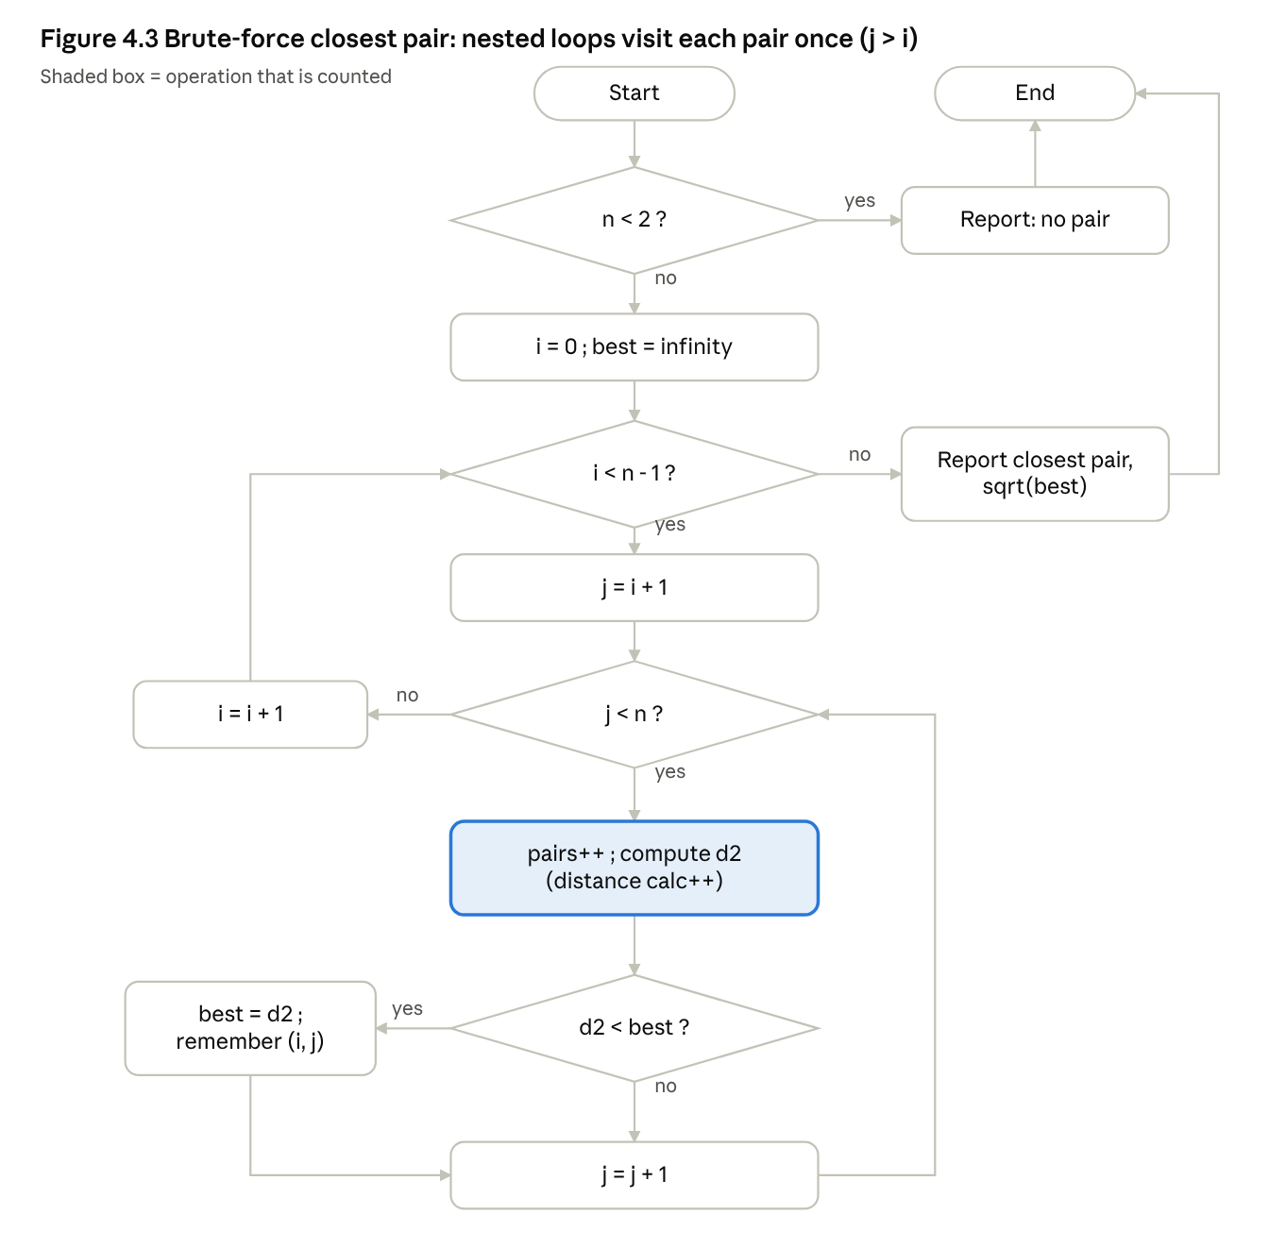
Brute-force closest pair flowchart · nested loops, each pair once

4.4 C code (full file: q4_closest.c; ./q4_closest stdin reads n then n lines x y)
static void closest_bf(const Pt p[], int n, Res *r){
r->pairs=r->dist=0; r->best_d2=-1; r->bi=r->bj=-1;
for(int i=0;i<n-1;i++)
for(int j=i+1;j<n;j++){ /* each unordered pair once */
r->pairs++;
long long dx=p[i].x-p[j].x, dy=p[i].y-p[j].y, d2=dx*dx+dy*dy; r->dist++;
if(r->best_d2<0 || d2<r->best_d2){ r->best_d2=d2; r->bi=i; r->bj=j; }
} }

4.5 Measured scaling (random hypothetical drones in a 10⁶ × 10⁶ square)
n | Predicted pairs n(n−1)/2 | Actual pairs | Distance calcs | Time (s)
10 | 45 | 45 | 45 | <0.0001
100 | 4,950 | 4,950 | 4,950 | <0.0001
1,000 | 499,500 | 499,500 | 499,500 | 0.0003
5,000 | 12,497,500 | 12,497,500 | 12,497,500 | 0.0090
10,000 | 49,995,000 | 49,995,000 | 49,995,000 | 0.0328
20,000 | 199,990,000 | 199,990,000 | 199,990,000 | 0.1366
40,000 | 799,980,000 | 799,980,000 | 799,980,000 | 0.5426
80,000 | 3,199,960,000 | 3,199,960,000 | 3,199,960,000 | 2.2357
The predicted and actual counts agree exactly for every n. Doubling n multiplies the pair count by ≈ 4 and the time by ≈ 4 (0.1366 → 0.5426 s is ×3.97; 0.5426 → 2.2357 s is ×4.12): quadratic growth.

4.6 Acceptable response time and practical limit
Criterion (my choice): one monitoring cycle must finish within 1 second on this machine, so positions can be rechecked about once per second. At ≈ 7×10⁻¹⁰ s per pair (measured at n = 40,000–80,000), 1 s allows ≈ 1.4×10⁹ pairs, i.e. n ≈ 54,000 (interpolated, not measured). A stricter 0.1 s threshold gives n ≈ 17,000. Real collision avoidance would need much tighter deadlines, and a slower device would reach its limit sooner, so these numbers describe only this experiment.

4.7 Where the inefficiency originates
Almost all examined pairs are drones far apart that cannot possibly be the closest pair, yet each is fully computed; and no result from one pair is reused to skip another (the current best distance is only used for a comparison, never to avoid work). A redesign must therefore reduce the number of candidate pairs – e.g. use an ordering or spatial grouping of the points so that pairs that are already known to be farther apart than the best distance found so far are never computed. Q7 develops and measures such a redesign.

Q5. Deriving a Brute-Force Convex Hull (7 marks)

5.1 Definitions
The convex hull of a set of points is the smallest convex polygon that contains all of them (like a rubber band stretched around nails). Boundary points lie on the polygon; hull vertices are the corner boundary points; interior points lie strictly inside. A shape is convex if the segment between any two of its points stays inside it.

5.2 From the geometric principle to a test
Given principle: a segment joining two points may be a hull edge if all other points lie on one appropriate side of the line through it.
Two points define a directed line. Take A = (aₓ,aᵧ) and B = (bₓ,bᵧ); the arrow A→B gives the line a direction, so “left” and “right” have a meaning. Which side is C on? Use the vectors AB = (bₓ−aₓ, bᵧ−aᵧ) and AC = (cₓ−aₓ, cᵧ−aᵧ), and the cross product (2-D determinant):
cross(A,B,C) = (bₓ−aₓ)(cᵧ−aᵧ) − (bᵧ−aᵧ)(cₓ−aₓ) = |AB|·|AC|·sin θ,
where θ is the angle turned counter-clockwise from AB to AC. Since |AB| and |AC| are positive, the sign is the sign of sin θ: > 0 → C is to the left (counter-clockwise turn), < 0 → right (clockwise), = 0 → collinear (θ = 0° or 180°). Equivalent derivation: the line through A and B is (bᵧ−aᵧ)x − (bₓ−aₓ)y + c = 0; substituting C gives the same expression up to the sign convention, so the value is the signed (scaled) distance of C from the line.
Figure 5.1 – left / right / on the line. For A=(0,0), B=(4,0): C=(2,3) → cross = 4·3 − 0 = +12 (left); C=(2,−3) → −12 (right); C=(2,0) → 0 (on the line, between A and B); C=(7,0) → 0 (on the line, beyond B).

5.3 Decision rule (my derivation)
A supporting line touches the point set with every point on one closed side. The hull is the intersection of all half-planes that contain the set, so a supporting line through two points marks a hull boundary. I choose the counter-clockwise convention: accept directed edge i→j when every other point k is left of it (cross > 0), with the degenerate cases:
- cross > 0 → fine.
- cross < 0 → a point is on the right: reject (stop checking early).
- cross = 0 → k is on the line. If k lies inside segment ij, it is a boundary point that is not a vertex: allowed. If it lies outside the segment, a longer edge exists, so ij is only part of an edge: reject.
Output = the accepted edges, chained by “next vertex” pointers into the CCW vertex list.
Pseudocode
remove duplicate points
for each ordered pair (i, j), i != j:
ok = true
for each k not in {i, j}:
c = cross(P[i], P[j], P[k])
if c < 0: ok = false; break
if c == 0 and k not inside segment(P[i], P[j]): ok = false; break
if ok: next[i] = j # accepted hull edge i -> j
start at any vertex with a next; follow next[] until back at start
Figure 5.2 – flowchart
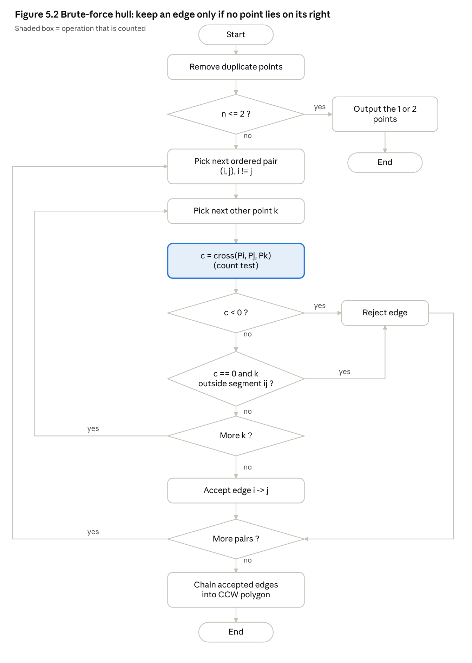
Brute-force convex hull flowchart · cross-product edge test

5.4 Why an accepted edge belongs to the boundary (geometric argument)
Suppose edge i→j is accepted. Then every point of the set lies in the closed half-plane to the left of the line L through P_i and P_j. A half-plane is convex, so it contains the whole hull (the smallest convex set containing the points). Thus the hull lies entirely on one side of L, and L touches the hull at P_i and P_j. The segment P_iP_j lies in the hull (convexity) and on L, so it lies on the boundary of the hull. Conversely, if one point is strictly right of L and another strictly left, L passes through the interior of the hull and the segment cannot be on its boundary, hence the rejection. So accepted edges are exactly the boundary edges, each supplied in the same rotational direction, which is why the chaining yields one closed polygon. The collinear rule makes edges maximal: a collinear point outside the segment would extend the edge, and one inside the segment merely lies along it.

5.5 Degeneracies and precision
Issue | Handling
Duplicate coordinates | Removed before the search (otherwise cross = 0 with a repeated point and the segment-test would be ambiguous).
Collinear points on an edge | Allowed inside the segment (not reported as vertices); only the extreme two become vertices.
All points collinear | The two extreme points accept each other in both directions → hull reported as the 2-point segment.
n = 1 or 2 | Returned directly.
Precision | Coordinates are integers and cross uses long long; the sign is exact for

5.6 C code (full file: q5_hull.c)
static long long cross(Pt a, Pt b, Pt c){ tests++;
return (b.x-a.x)*(c.y-a.y)-(b.y-a.y)*(c.x-a.x); }
static int hull_bf(Pt p[], int n, int hull[], int *edges){
/* ... for i, for j!=i ... */
for(int k=0;k<n&&ok;k++){ if(k==i||k==j) continue;
long long c=cross(p[i],p[j],p[k]);
if(c<0) ok=0; /* point on the right */
else if(c==0 && !between(p[i],p[j],p[k])) ok=0; /* collinear, outside segment */
}
if(ok){ (*edges)++; if(next[i]<0) next[i]=j; }
/* then follow next[] from the first vertex to build the CCW list */ }

5.7 Test configurations (hypothetical) and measured results
Config A – boundary + interior (12 points): (2,1) (9,2) (12,6) (10,11) (4,12) (1,7) | interior: (5,5) (7,7) (6,3) (8,9) (4,8) (9,5). Measured hull (CCW): (2,1) (9,2) (12,6) (10,11) (4,12) (1,7); 6 accepted edges; 290 orientation tests (worst-case bound n(n−1)(n−2) = 1,320).
12 . . . . H . . . . . . . .
11 . . . . . . . . . . H . . .
9 . . . . . . . . o . . . . .
8 . . . . o . . . . . . . . .
7 . H . . . . . o . . . . . .
6 . . . . . . . . . . . . H .
5 . . . . . o . . . o . . . .
3 . . . . . . o . . . . . . .
2 . . . . . . . . . H . . . .
1 . . H . . . . . . . . . . .
0 1 2 3 4 5 6 7 8 9 0 1 2 3 (H = hull vertex, o = interior; empty rows omitted)
Config B – challenge case (15 input points): corners (0,0) (10,0) (10,10) (0,10); collinear points on edges (5,0) (5,10) (0,5) (10,5); an interior point (5,5) and (2,2); duplicates (5,5), (0,0), (10,0), (5,10); and an extra vertex (12,5) that turns the right edge into two edges, which makes (10,5) interior. After removing duplicates: 11 points. Measured hull (CCW): (0,0) (10,0) (12,5) (10,10) (0,10); 5 edges; 266 tests (bound 990). The collinear points (5,0), (5,10), (0,5) were correctly not reported as vertices, and the left edge (0,10)→(0,0) was accepted although (0,5) lies on it.
Other checks (Measured): 5 collinear points (0,0)…(5,5) → 2-point hull (0,0)–(5,5); single point → itself; two points → the segment.

5.8 Growth of work (random hypothetical points in 1000×1000)
n (after duplicates) | Orientation tests | Worst-case n(n−1)(n−2) | Ratio
25 | 1,731 | 13,800 | 0.125
50 | 7,697 | 117,600 | 0.066
100 | 39,213 | 970,200 | 0.040
200 | 116,104 | 7,880,400 | 0.015
400 | 425,882 | 63,520,800 | 0.0067
799 | 1,733,189 | 508,168,794 | 0.0034
Theory: n(n−1) ordered pairs, each checked against up to n−2 points, gives a worst case of Θ(n³). Measured work grows more slowly (×3.0, ×3.7, ×4.1 per doubling at the large end, i.e. nearly quadratic) because a wrong pair is usually rejected after only a few points: the cost is ≈ (n² pairs × a few tests) + (h accepted edges × (n−2) full scans), with hull size h only 8–16 here. The cubic worst case would appear if most pairs survive long scans (e.g. all points on a circle, or on a line); that case was not measured here. Speed was not important: n = 799 took 0.0075 s.

Q6. Exhaustive Search for Humanitarian Airlift Planning (8 marks)

6.1 Problem and representation
Each package has an ID, a weight w and a humanitarian value v. We must choose a set of packages with total weight ≤ the payload limit C that maximises total value. This is the 0/1 selection problem: each package is either taken or not.
Representation. For n packages use n binary decision variables x₀…xₙ₋₁ (xᵢ = 1 means package i is loaded). A whole selection is an n-bit number (bitmask); counting from 0 to 2ⁿ−1 generates every combination exactly once. Each package has two options (in/out), so the number of subsets is 2 × 2 × … × 2 = 2ⁿ (this includes the empty set and the set of everything).
Procedure. For every mask: (1) compute total weight W = Σ wᵢxᵢ and value V = Σ vᵢxᵢ; (2) if W > C, reject it (infeasible); (3) otherwise if V is greater than the best value so far, keep this mask as the best. After the last mask the kept selection is optimal, because every feasible selection was compared. Time Θ(n·2ⁿ) with the simple per-mask loop used here (Θ(2ⁿ) with incremental updates); extra space O(1).
Figure 6.1 – flowchart
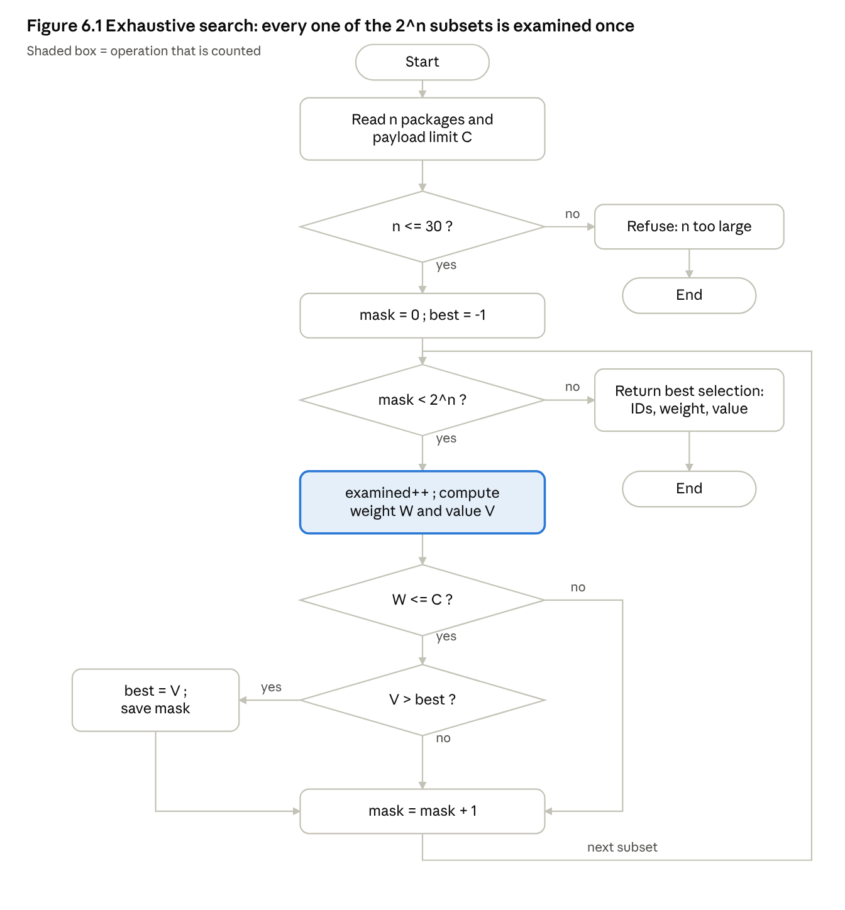
Exhaustive search flowchart · all 2^n subsets examined
Figure 6.2 – subset tree for 3 packages (binary strings P3P2P1): 000 → 001 → 010 → 011 → 100 → 101 → 110 → 111. Equivalently the tree branches “exclude/include P1”, then P2, then P3: 2 → 4 → 8 leaves, and every leaf is one subset.

6.2 Worked example (hypothetical dataset) with independent verification
Packages: P1 (w=3, v=40), P2 (w=5, v=50), P3 (w=4, v=45), P4 (w=2, v=20), P5 (w=6, v=60). Payload limit C = 10. 2⁵ = 32 subsets (Measured output; bit string = P5 P4 P3 P2 P1):
# | Bits | W | V | Status | # | Bits | W | V | Status
0 | 00000 | 0 | 0 | feasible, best | 16 | 10000 | 6 | 60 | feasible
1 | 00001 | 3 | 40 | feasible, best | 17 | 10001 | 9 | 100 | feasible
2 | 00010 | 5 | 50 | feasible, best | 18 | 10010 | 11 | 110 | overweight
3 | 00011 | 8 | 90 | feasible, best | 19 | 10011 | 14 | 150 | overweight
4 | 00100 | 4 | 45 | feasible | 20 | 10100 | 10 | 105 | feasible
5 | 00101 | 7 | 85 | feasible | 21 | 10101 | 13 | 145 | overweight
6 | 00110 | 9 | 95 | feasible, best | 22 | 10110 | 15 | 155 | overweight
7 | 00111 | 12 | 135 | overweight | 23 | 10111 | 18 | 195 | overweight
8 | 01000 | 2 | 20 | feasible | 24 | 11000 | 8 | 80 | feasible
9 | 01001 | 5 | 60 | feasible | 25 | 11001 | 11 | 120 | overweight
10 | 01010 | 7 | 70 | feasible | 26 | 11010 | 13 | 130 | overweight
11 | 01011 | 10 | 110 | feasible, new best (final) | 27 | 11011 | 16 | 170 | overweight
12 | 01100 | 6 | 65 | feasible | 28 | 11100 | 12 | 125 | overweight
13 | 01101 | 9 | 105 | feasible | 29 | 11101 | 15 | 165 | overweight
14 | 01110 | 11 | 115 | overweight | 30 | 11110 | 17 | 175 | overweight
15 | 01111 | 14 | 155 | overweight | 31 | 11111 | 20 | 215 | overweight
Result: examined = 32 (= 2⁵), feasible = 17, best = {P1, P2, P4}, weight 10, value 110.
Independent verification (two ways). (1) By hand: the highest-valued sets are all overweight (all five = 215 at W=20; any set with value > 110 has weight > 10 in the table). The best near-misses that fit are {P3,P5} = 105 at W=10, {P1,P3,P4} = 105 at W=9, {P1,P5} = 100 at W=9. (2) The program also runs a different algorithm, a dynamic-programming knapsack table, which returned 110. The two methods agree, so the enumeration finds the optimum. (Greedy by value/weight ratio would give P1 (13.3), P4 (10), P3 (11.25) → P1+P3+P4 = 105: also showing why a simple shortcut is not safe.)

6.3 C code (full file: q6_airlift.c)
#define MAXN 30 /* 2^30 masks fits in 32 bits and bounds run time */
static void exhaustive(const Pkg p[], int n, int cap, Res *r){
r->examined=r->feasible=0; r->bestv=-1; r->bestw=0; r->mask=0;
for(unsigned long long m=0; m<(1ULL<<n); m++){
r->examined++; int w=0, v=0;
for(int i=0;i<n;i++) if(m>>i & 1){ w+=p[i].w; v+=p[i].v; }
if(w<=cap){ r->feasible++;
if(v>r->bestv){ r->bestv=v; r->bestw=w; r->mask=(unsigned)m; } } } }

6.4 Growth prediction and measurements
Prediction (before running): candidates examined = 2ⁿ exactly; each extra package doubles the count, so time should roughly double (slightly more than double because each mask costs n steps). Packages here are hypothetical (weights 1–20, values 1–50, fixed seed); the payload limit is half the total weight.
n | Predicted subsets 2ⁿ | Actual examined | Feasible | Time (s) | Optimal value | DP check
10 | 1,024 | 1,024 | 530 | <0.0001 | 138 | 138
15 | 32,768 | 32,768 | 16,384 | 0.0018 | 286 | 286
20 | 1,048,576 | 1,048,576 | 532,156 | 0.0636 | 362 | 362
22 | 4,194,304 | 4,194,304 | 2,097,152 | 0.2598 | 371 | 371
24 | 16,777,216 | 16,777,216 | 8,388,608 | 1.0786 | 405 | 405
26 | 67,108,864 | 67,108,864 | 33,991,759 | 4.5614 | 490 | 490
28 | 268,435,456 | 268,435,456 | 135,890,595 | 18.6370 | 538 | 538
The counts match 2ⁿ exactly and the DP check agrees in every row. Time grows ×≈ 4.1–4.2 for every 2 extra packages (22→24: ×4.15; 24→26: ×4.23; 26→28: ×4.09), consistent with doubling per package (×4 per two). Cost per subset ≈ 64–70 ns.

6.5 Why a few extra packages cause a dramatic increase
The solution space is the set of subsets, and each new package doubles it: it can be added to every one of the existing subsets or left out. Adding k packages multiplies the work by 2ᵏ (not by adding k units): adding 10 packages gives ×1,024, so going from 20 to 30 packages makes the search about a thousand times longer. Measured: going from n = 20 to n = 28 (8 more packages) multiplied the subsets by 256 and the time by ≈ 293 (0.0636 s → 18.64 s). Growth is exponential, so polynomial speed-ups of the hardware cannot keep pace.

6.6 Deployment decision
Response-time limit (my choice): 1 second, since the planner needs to re-plan a loading decision interactively when package lists change. Measured: n = 22 took 0.26 s (inside the limit) and n = 24 took 1.08 s (just outside). I would deploy the exhaustive solution up to n = 22 packages (measured evidence); n = 23 is estimated at ≈ 0.5 s by interpolation (not measured), and anything beyond n = 24 exceeds the limit. Extrapolating the measured ≈ ×2 per package, n = 30 would take ≈ 75 s (an estimate, not measured). This boundary depends on the machine and the limit; a 10 s limit would allow n ≈ 27. Beyond the boundary a different strategy is needed (see the note in 7.8).

Q7. Diagnose, Redesign and Validate (13 marks)

7.0 Selection of the solution to redesign
Reviewing Q1–Q6: Q6 is exponential, but its bottleneck cannot be reduced by a small, clearly measurable change; Q4 (closest pair) has a quadratic cost whose origin is simple, visible in the data and addressable with an implementable idea; Q2 and Q3 are cheap on realistic data. I selected Q4, Brute-Force Closest Pair, because its measured limit (n ≈ 54,000 for a 1-second response) is a real computational limitation and both original and redesign can be run on identical datasets.

7.A Diagnose the bottleneck (2 marks)
- Where the effort goes: 100% of the dominant work is the distance calculation (and loop control around it). The measured counts show exactly n(n−1)/2 distance calculations: 499,500 at n = 1,000; 12,497,500 at n = 5,000; 799,980,000 at n = 40,000.
- How it grows: quadratically – doubling n multiplies the count by ≈ 4 (time ×3.97 and ×4.12 in Q4).
- Unnecessary / repeated work: the answer for n = 5,000 random drones in a 10⁶ square is a distance of about 131, but the algorithm also fully computed the distances of ~12.5 million pairs that are hundreds of thousands of units apart. A pair whose x-coordinates already differ by more than the best distance found so far cannot be the closest pair, yet it is computed. For uniform data the fraction of pairs whose x-gap is below dₘᵢₙ is about 2dₘᵢₙ/10⁶ ≈ 2.6×10⁻⁴, so roughly 99.97% of the computed pairs were unable to matter.
- Causing characteristic: the algorithm treats the points as an unordered bag, so it has no way to know which pairs are far apart without computing them, and it never uses the current best distance to avoid any work.

7.B Design objective (2 marks)
Objective: reduce distance calculations by at least 90% (a factor ≥ 10) for uniform random drone sets with n ≥ 5,000, while returning exactly the same minimum distance as the original. Primary metric: number of distance calculations; to stay honest about the new overhead, the total key operations = sort comparisons + x-gap checks + distance calculations is also reported. Supplementary metric: time. Test conditions: same datasets for both versions: uniform (n = 1,000, 5,000, 10,000, 20,000, 40,000), 20 tight clusters (n = 10,000), a thin vertical strip (n = 10,000), and a deliberately adversarial set with all x-coordinates equal (n = 10,000).

7.C Revised strategy (4 marks)
What changes. Sort the points once by x. Then, for each point i, examine later points j = i+1, i+2, … in x order and stop the inner loop as soon as (xⱼ − xᵢ)² ≥ best, where best is the smallest squared distance found so far.
Property exploited. After sorting, the x-gaps from point i to later points never decrease. For any pair, d² ≥ (x-gap)². So once the x-gap squared reaches best, every later point j′ has d²(i,j′) ≥ (x-gap)² ≥ best and cannot be a strictly closer pair; skipping them cannot change the answer. This reuses information (best distance) and exploits an order (sorted x).
What is reduced: distance calculations for far-apart pairs. What is added: one sort (O(n log n) comparisons), one cheap x-gap check per examined candidate (cheaper than a distance calculation), and O(n) extra memory for the sorted copy (O(1) if sorted in place). Trade-offs: (i) preprocessing cost; (ii) the benefit depends on the data: if many points share nearly the same x (vertical line), the x-gap never exceeds best and the inner loop never stops early, so the cost is still Θ(n²) plus the sort. This is why the adversarial dataset is included.
Pseudocode
sort P by x # preprocessing
best = infinity
for i = 0 .. n-2:
for j = i+1 .. n-1:
dx = P[j].x - P[i].x
if dx*dx >= best: break # all later j are at least as far in x
d2 = dx*dx + (P[j].y-P[i].y)^2
if d2 < best: best = d2; remember (i, j)
return closest pair, sqrt(best)
Figure 7.1 – revised flowchart
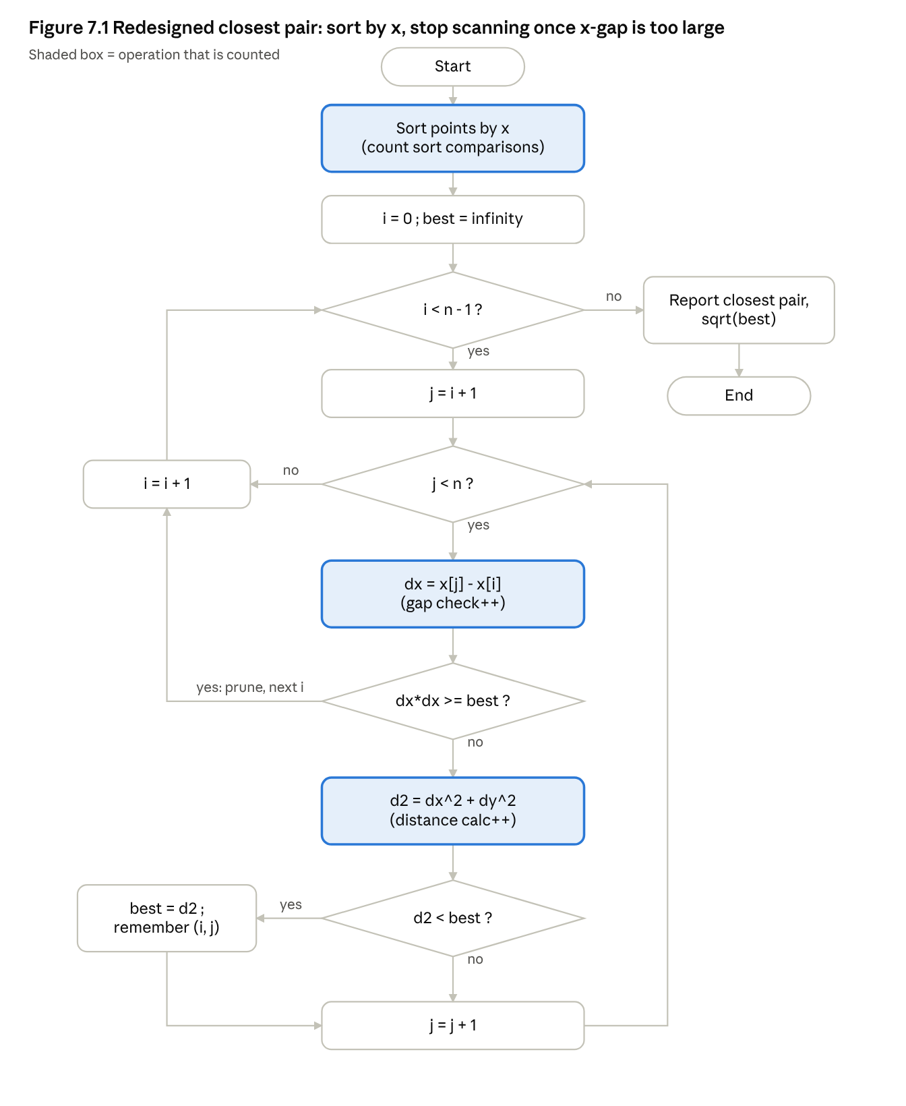
Redesigned closest pair flowchart · sorted sweep with pruning

7.D Prediction made before running the redesign (1 mark)
- For uniform random points, distance calculations will fall by more than 99% at n = 10,000 and grow close to linearly with n (roughly doubling when n doubles), because only points within an x-window about as wide as the closest distance are examined; total key operations (including the sort) should still be at least 100× smaller at n = 10,000.
- Clustered and thin-strip data will also be strongly reduced.
- On the adversarial all-equal-x data, no reduction is expected (ratio ≈ 1) and the redesign will be slightly slower in time because of the sort.
- Both versions must report the same minimum distance on all datasets.

7.E Implementation and validation (2 marks)
File: q7_closest_redesign.c (original and redesign in one program, same generated data fed to both; the program checks that both return the same minimum squared distance). Core of the redesign:
qsort(p, n, sizeof(Pt), cmpx); /* preprocessing: sort by x, counting comparisons */
for(int i=0;i<n-1;i++) for(int j=i+1;j<n;j++){
long long dx=p[j].x-p[i].x; r->gap++; /* cheap x-gap check */
if(r->d2>=0 && dx*dx>=r->d2) break; /* prune: all later j are too far in x */
long long dy=p[j].y-p[i].y, d=dx*dx+dy*dy; r->dist++;
if(r->d2<0||d<r->d2) r->d2=d; }
Measured comparison, original → redesign (same data for both; hypothetical random drones; coordinates in a 10⁶ range, the strip set has x < 1000, the all-equal set has x = 500 and y up to 10⁹):
Dataset | n | Original dist. calcs | Redesign dist. calcs | Gap checks | Sort comparisons | Redesign total key ops | Same min distance?
Uniform | 1,000 | 499,500 | 1,663 | 2,662 | 8,710 | 13,035 | yes
Uniform | 5,000 | 12,497,500 | 6,525 | 11,523 | 55,130 | 73,178 | yes
Uniform | 10,000 | 49,995,000 | 19,601 | 29,599 | 120,392 | 169,592 | yes
Uniform | 20,000 | 199,990,000 | 19,844 | 39,842 | 260,983 | 320,669 | yes
Uniform | 40,000 | 799,980,000 | 68,298 | 108,296 | 561,699 | 738,293 | yes
20 clusters | 10,000 | 49,995,000 | 14,673 | 24,671 | 120,466 | 159,810 | yes
Thin strip (x<1000) | 10,000 | 49,995,000 | 207,800 | 217,790 | 120,475 | 546,065 | yes
All x equal (adversarial) | 10,000 | 49,995,000 | 49,995,000 | 49,995,000 | 64,608 | 100,054,608 | yes
Improvement factors (derived from the table; time is supplementary, single run):
Dataset | n | Distance-calc reduction | Key-op reduction (orig. calcs ÷ redesign total) | Original time (s) | Redesign time (s) | Time speed-up
Uniform | 1,000 | 300× | 38× | 0.0005 | 0.0001 | 4.1×
Uniform | 5,000 | 1,915× | 171× | 0.0132 | 0.0007 | 18.9×
Uniform | 10,000 | 2,551× | 295× | 0.0511 | 0.0016 | 32.0×
Uniform | 20,000 | 10,078× | 624× | 0.2111 | 0.0036 | 58.9×
Uniform | 40,000 | 11,713× | 1,084× | 0.8349 | 0.0071 | 118×
20 clusters | 10,000 | 3,407× | 313× | 0.0515 | 0.0017 | 31.1×
Thin strip | 10,000 | 241× | 92× | 0.0510 | 0.0016 | 32.4×
All x equal | 10,000 | 1.0× (none) | 0.5× (worse: 2× more operations) | 0.0532 | 0.0599 | 0.9× (slower)
Redesign-only scaling (the original is too slow to run at these sizes; uniform data, q7_large.c):
n | Distance calcs | Gap checks | Sort comparisons | Time (s)
100,000 | 123,753 | 223,751 | 1,536,483 | 0.0208
200,000 | 236,285 | 436,284 | 3,272,795 | 0.0489
500,000 | 918,142 | 1,418,140 | 8,837,431 | 0.1375
1,000,000 | 701,842 | 1,701,839 | 18,674,884 | 0.2674
2,000,000 | 1,349,677 | 3,349,676 | 39,348,337 | 0.5296
Note: absolute times vary between runs (the original at n = 40,000 took 0.8349 s in this program but 0.5426 s in the Q4 program on different random points), which is why operation counts are the primary evidence.

7.F Defence of the final design (2 marks)
Was the prediction supported? Yes on every point, with one qualification. (1) Distance calculations fell by 99.96% at n = 10,000 (49,995,000 → 19,601) and total key operations including the sort were 295× smaller (prediction ≥ 100×). (2) Clusters (3,407×) and the thin strip (241×) also improved a lot. (3) The all-equal-x set showed no reduction and the redesign was slightly slower (0.0599 s vs 0.0532 s), as predicted. (4) All minimum distances matched. Qualification: “close to linear growth” held on average (n ×40 from 1,000 to 40,000 gave ×41 more distance calculations) but not smoothly (calculations were almost unchanged between n = 10,000 and 20,000), because the count depends on how early a small best distance is found. This is one random sample per size, so I do not claim a precise growth law.
Magnitude of improvement. For typical (uniform / clustered) data the operation count fell from quadratic to roughly “sort plus about linear”, a 38× to 1,084× reduction in key operations for n = 1,000–40,000, and the objective (≥ 10×) was met at every uniform size. Using the same 1-second criterion as Q4, the original reached its limit at about n ≈ 54,000 (interpolated), whereas the redesign took 0.53 s at n = 2,000,000 (measured), so the practical limit moved by at least ≈ 37× (its own 1-second point would be about n ≈ 3.8 million by extrapolation, not measured).
New costs and trade-offs. (a) The bottleneck has moved: at n = 10,000 the sort comparisons are 71% of the redesign’s operations (120,392 of 169,592) and at n = 2,000,000 they are about 89% (39.3 M of 44.1 M), so the new cost is O(n log n) sorting. (b) O(n) extra memory for the sorted copy (or reordering of the caller’s data if sorted in place). (c) Extra x-gap checks (about 1.5–2× as many as distance calculations). (d) Data dependence: the worst case is still Θ(n²) – shown by the all-equal-x set and weakened on the thin strip. This is realistic for drones flying along a north–south corridor.
When the original may be preferable. Very small n (the overhead of sorting is pointless, e.g. n ≤ about 50 where both are instantaneous and the simple loop is easiest to verify); inputs that are all or mostly aligned in x (the original cost is then about half the redesign’s); settings where the input must not be reordered or extra memory is unavailable; and when absolute simplicity matters.
Does it sufficiently address the limitation? It fixes the diagnosed bottleneck for typical spreads of points: far-apart pairs are no longer computed. It does not remove the quadratic worst case. A more robust design (not implemented here) would also use the y-coordinate, e.g. choosing the axis with the larger spread or a grid/strip method, so that vertical alignment cannot defeat the pruning. Final conclusion: the redesign is a clear success on varied data and an honest failure on adversarially aligned data, and both outcomes follow from the pruning property that it exploits.

7.8 Note on the other questions
For Q6 the same style of diagnosis applies (all 2ⁿ subsets are generated even when a partial selection is already overweight); a pruned search (stop extending a selection once it exceeds the payload limit) would cut candidates, but it was not implemented or measured here, so no result is claimed for it.

8. Reproducing the Results
gcc -O2 -o q1_sorting q1_sorting.c -lm && ./q1_sorting
gcc -O2 -o q2_seqsearch q2_seqsearch.c -lm && ./q2_seqsearch
gcc -O2 -o q3_strmatch q3_strmatch.c -lm && ./q3_strmatch
gcc -O2 -o q4_closest q4_closest.c -lm && ./q4_closest # ./q4_closest stdin for your own points
gcc -O2 -o q5_hull q5_hull.c -lm && ./q5_hull
gcc -O2 -o q6_airlift q6_airlift.c -lm && ./q6_airlift # takes ~25 s (n up to 28)
gcc -O2 -o q7_closest_redesign q7_closest_redesign.c -lm && ./q7_closest_redesign
gcc -O2 -o q7_large q7_large.c -lm && ./q7_large
Operation counts are deterministic (fixed seeds) and should be identical on your machine; times will differ. Raw output files are in raw_outputs/ in the zip. To test your own data in Q1–Q3 and Q5–Q6 edit the arrays in main.

9. Final Conclusion
- Q1: No single sort is always best. Selection always costs n(n−1)/2 comparisons; Bubble and Insertion adapt, but for the 95%-sorted centre Insertion Sort used about 20× fewer comparisons (24,063 vs ≈ 498,000).
- Q2: Sequential search costs exactly position + 1 comparisons for hits and n for misses; reasonable for small lists with constant change and low query rate, but both n and lookup rate multiply with 20 facilities (≈ 400× work), so an index such as a hash table should be considered.
- Q3: Same-size inputs cost 997 vs 9,910 comparisons depending on structure: input size alone does not predict work.
- Q4: Pair counts matched n(n−1)/2 exactly; with a 1 s limit the brute force reaches its limit near n ≈ 54,000 on this machine.
- Q5: The cross-product test gave correct hulls for interior, collinear and duplicate points; the correctness follows from the supporting-line argument.
- Q6: Subsets examined = 2ⁿ exactly; time ×≈ 4 for each 2 added packages; with a 1 s limit I would deploy up to n = 22 packages.
- Q7: Pruning closest-pair by sorted x cut distance calculations by 99.96% at n = 10,000 and 38–1,084× in total operations, but offers no benefit when all points share one x-coordinate.

